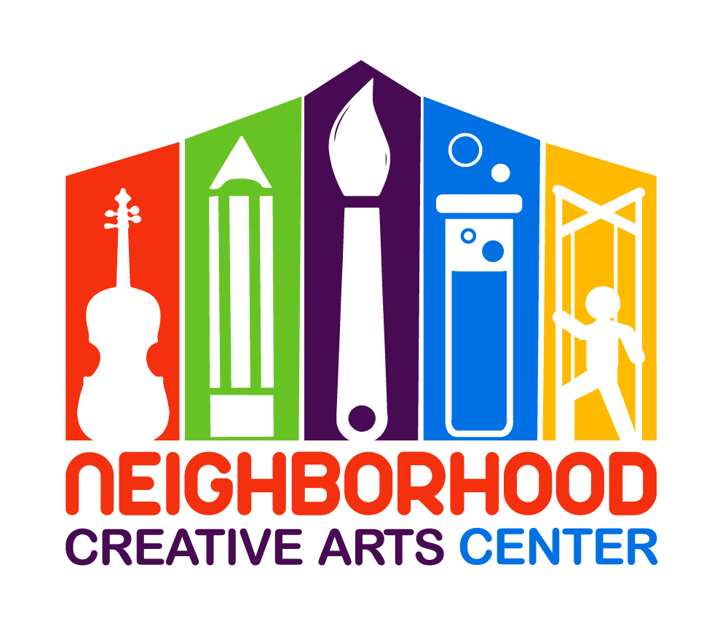
NCAC Pre-K Piano
Registration form for 2019-2020

(This program is customized for students not yet of Kindergarten age in 2019-20.)

Student’s name __________________________________________________________
Date of Birth _________________________ Age ________________________________
Home phone _____________________________________________________________
Home Address ____________________________________________________________
Parent or guardian name ____________________________________________________
Daytime phone____________________ Cell phone_________________________
E-mail address ______________________________________________________
Parent or guardian name ____________________________________________________
Daytime phone____________________ Cell phone__________________________
E-mail address _______________________________________________________
Are there any personal circumstances of which I should be aware (special needs, allergies, health problems, etc?) No_______ Yes ________ (I am enclosing a confidential statement.)
Who may we thank for referring you to us? _______________________________________

Pre-K Piano Tuition Schedule
(34 weeks of instruction, September 9, 2019 through June 6, 2020)
Please circle type of payment:

34 weeks of instruction: $90/month for 10 months
OR $450 semi-annual payment due 20 August, 2019
and 20 January, 2020
OR Full payment of $900
Materials Fee
Students will need $120 for materials. This fee covers music books, accompanying CDs, an assignment binder, backpack and additional teaching aids; Piano Party materials; and recital fees. This fee must be paid along with registration. Your payment of this fee is a sign of commitment from you, allowing us to reserve your preferred lesson time for your child.
Scheduling
Please let us know your top three choices for a lesson time. We have listed the days and times that Pre-K piano lessons are available. The more specific you can be, the more likely we will be able to arrange a convenient time for you.

Monday (3-8PM): ____________________
Tuesday (3-8PM): ____________________
Wednesday (3-8PM): _________________
Thursday (3-8PM): ___________________
Friday (3-8PM): ______________________
Saturday (8AM-12 noon): ______________

Your child will attend a Piano Party every fourth week in place of their individual lesson. The Pre-K Piano Party will be on Thursday, 4:30-5:30, every fourth week. A Piano Party schedule will be placed in your child’s binder and can be found on the Events page of the MGCAA website.

IMPORTANT
- I have read and agree to the terms of the current Neighborhood Creative Arts Center Registration Form, Financial Agreement and Attendance Agreement.
- I accept full liability for my child while at NCAC.
- The following items must be turned in at the time of registration: completed Registration form, Financial Agreement, and materials deposit.
- I understand that my child’s picture may be used in print and electronic media. If I am not comfortable with this, I will notify Ms. Georgia in writing within 2 weeks of registration.
- Payment may be made with cash, checks payable to NCAC, Cash App ($GeorgiaBonney), Venmo (Georgia-Bonney-1), or PayPal (through msgeorgia@neighborhoodcreativeartscenter.org, please include 3% service charge).
- Refunds will not be made for lessons or classes missed or canceled by the student.

____________________________________________________ ______________________
(Signature of Parent, Guardian, or Adult Student) Date

