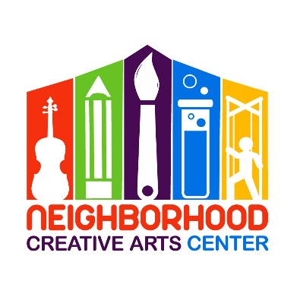
NCAC Virtual Music Academy
Individual Lessons
Financial Responsibility Contract
2021-2022

By signing this agreement, you acknowledge your financial responsibilities to the Neighborhood Creative Arts Center. You are acknowledging that you have read, understand, and agree to our Attendance Agreement.
Tuition may be paid for the entire year, for half year, or in monthly tuition installments. Tuition installments are due on the 20th of each month, August, 2021 - May, 2022. Please see detailed summary of tuition below.
A materials fund for each student must be established at the beginning of your musical studies. This includes all music for the entire year. The annual materials fee is $50/year and must be paid along with registration as a sign of commitment, allowing us to reserve your preferred lesson time for you. Without this payment, your lesson time may be claimed by another student.
Commitment is for a 33-week term and unless we receive a 30-day notification of withdrawal, we assume you will be continuing your musical journey with us until the end of the school year.
Tuition installments paid after the 20th will incur a $15 late fee. If this late fee is not added to the tuition payment, it will be deducted from the materials deposit. Payment not made by the 30th of the month will result in lesson termination. All past-due accounts receive a courtesy email and text/phone call before lesson termination occurs. Should something come up where you cannot financially fulfill your commitment to your music lessons, we appreciate and encourage advanced notice and open, ongoing communication with us.

Tuition Fees for 33 weeks of instruction
30-minute lessons: $1150 total annual payment*
OR
$575* semi-annual payment due August 20, 2021 and
January 20, 2022
OR
10 monthly payments of $115 due on the
20th of each month, August, 2021 through May, 2022

45-minute lessons: $1500 total annual payment*
OR
$750* semi-annual payment due August 20, 2021 and
January 20, 2022
OR
10 monthly payments of $150 due on the
20th of each month, August, 2021 through May, 2022

Payment may be made with CashApp ($GeorgiaBonney), Venmo (GeorgiaBonney-1), or PayPal (through msgeorgia@neighborhoodcreativeartscenter.org, please include 3% service charge).
** If you are joining mid-term, a prorated Tuition Schedule will be emailed to you, which you will sign in place of this page.

Materials Fee ($50): Due upon registration. Payment of this fee is a sign of your commitment, allowing us to reserve your preferred lesson time for you. Without payment, your preferred lesson time may be claimed by another student.

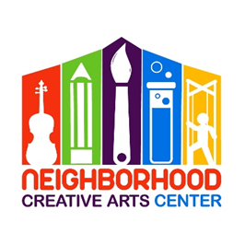
NCAC Virtual Music Academy
Individual Lesson
2021- 2022 Tuition Schedule

(Please keep this page for your records.)

Materials fee: $50, to reserve lesson time; covers music for the year
Tuition Installment Amounts (due monthly for 10 months):
30-minute lessons: $115
45-minute lessons: $150

Tuition Schedule:
At time of Registration: $50 materials fee
20 August: Tuition Installment #1
20 September: Tuition Installment #2
20 October: Tuition Installment #3
20 November: Tuition Installment #4
20 December: Tuition Installment #5
20 January: Tuition Installment #6
20 February: Tuition Installment #7
20 March: Tuition Installment #8
20 April: Tuition Installment #9
20 May: Tuition Installment #10

