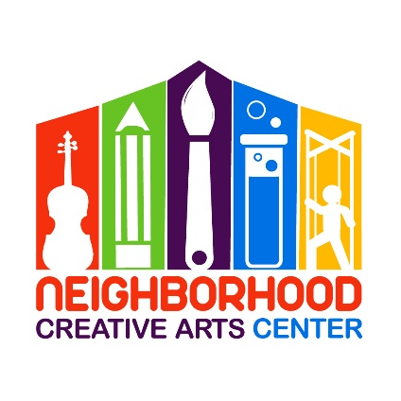
Chamber Ensemble
Registration Form for 2020
Term 2: January 11 – June 6, 2020

Student’s name _____________________________________________________________
Term attending: Term 1 Term 2
Instrument _________________________________________________________________
Date of Birth ______________________________ Age _____________________________
School attending ______________________________________Grade Level____________
Home address _______________________________________________________________
City__________________________ State________ Zip Code__________________________
Parent or guardian name _______________________________________________________
Daytime phone____________________ Cell phone_______________________
E-mail address ___________________________________________________
Parent or guardian name ________________________________________________
Daytime phone____________________ Cell phone_______________________
E-mail address ____________________________________________________

Are there any personal circumstances of which I should be aware (special needs, allergies, health problems, etc?) No_______ Yes ________ (I am enclosing a confidential explanation.)
Are there any family religious beliefs that might impact repertoire choices or performance dates?
If so, please explain: __________________________________________________________________________
Who may we thank for referring you to us? ________________________________________________________

Tuition schedule and Materials Fee
Tuition will be $20/rehearsal. Tuition will be determined on a case by case basis, dependent on the number of rehearsals. Materials will be provided and fees will be determined at that time.

IMPORTANT
- I have read and agree to the terms of the current Neighborhood Creative Arts Center Registration Form.
- I accept full responsibility for my child while at NCAC.
- The following items must be turned in at time of registration: completed Registration form and agreed tuition and materials fee.
- I understand that my child’s picture may be used in print and electronic media. If I am not comfortable with this, I will notify Ms. Georgia in writing within 2 weeks of registration.
- Payment may be made with cash, checks payable to NCAC, Cash App ($GeorgiaBonney), Venmo (Georgia-Bonney-1), or PayPal (through msgeorgia@neighborhoodcreativeartscenter.org, please include 3% service charge).
- Refunds and credits will not be made for rehearsals missed or canceled by the student.

_________________________________________________________________________
(Signature of Parent, Guardian, or Adult Student) Date

