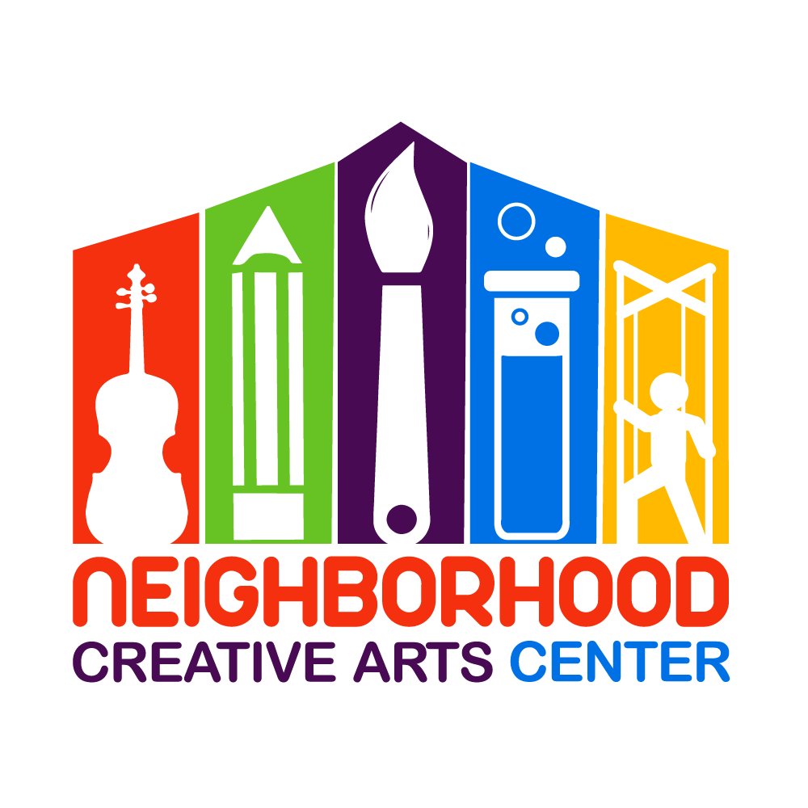
Music Center Individual Lessons
Financial Responsibility Contract
Adult Student
2019-2020
By signing this agreement, you acknowledge your financial responsibilities to Neighborhood Creative Arts Center. You are acknowledging that you have read, understand and agree to our Attendance Agreement, available at neighborhoodcreativeartscenter.org.
Tuition may be paid for the entire year, for half-year, or in monthly tuition installments. Tuition installments are due on the 20th of each month, August, 2019- May, 2020. Please see detailed summary of tuition below.
A materials fund for each student must be established at the beginning of your musical studies. This includes all administrative fees, assignment binder, copy fee, and music books for the entire year. The annual materials fee is $80/year and must be paid along with registration as a sign of commitment, allowing us to reserve your preferred lesson time for you. Without this payment, your lesson time may be claimed by another student.
Commitment is for a 24-week term and unless we receive a 30-day notification of withdrawal, we assume you will be continuing your musical journey with us until the end of the school year. Your lessons will happen on a 3 week on, one week off, schedule. This schedule will be given to you at the beginning of the year and is available on the NCAC website under “Events”.
Tuition installments paid after the 20th will incur a $15 late fee. If this late fee is not added to the tuition payment, it will be deducted from the materials deposit. Payment not made by the 30th of the month will result in lesson termination. All past-due accounts receive a courtesy email and text/phone call before lesson termination occurs. Should something come up where you cannot financially fulfill your commitment to your music lessons, we appreciate and encourage advanced notice and open, ongoing communication with us.
Tuition Fees for 24 weeks of instruction (3 weeks on, 1 week off)
30 minute lessons: $800 total annual payment
OR
$400 semi-annual payment due 20 August, 2019 and
20 January, 2020
OR
10 monthly payments of $80 due on the
20th of each month, August, 2019 through May, 2020

45 minute lessons: $1150 total annual payment
OR
$575 semi-annual payment due 20 August, 2019 and
20 January, 2020
OR
10 monthly payments of $115 due on the
20th of each month, August, 2019 through May, 2020

** If you are joining mid-term, a prorated Tuition Schedule will be emailed to you, which you will sign in place of this page.

Materials Fee ($80): Due upon registration. Payment of this fee is a sign of your commitment, allowing us to reserve your preferred lesson time for you. Without payment, your preferred lesson time may be claimed by another student.

Signature _________________________________________________________________
Today’s Date_______________________________________________________________
Email _____________________________________________________________________
NCAC Individual Lesson
2019-2020 Tuition Schedule

(Please keep this page for your records.)

At time of Registration: $80 materials fee, to reserve lesson time
20 August: Tuition Installment #1
20 September: Tuition Installment #2
20 October: Tuition Installment #3
20 November: Tuition Installment #4
20 December: Tuition Installment #5
20 January: Tuition Installment #6
20 February: Tuition Installment #7
20 March: Tuition Installment #8
20 April: Tuition Installment #9
20 May: Tuition Installment #10

Tuition Installment Amounts:
30-minute lessons: $80
45-minute lessons: $115

