Center
Music Center Individual Lessons
Registration Form for 2019-2020
Student’s Name
___________________________________________________
Specialty/Specialties to be studied (piano, voice, instrument) ______________________________
Has your child studied music privately previously outside of NCAC? ____________________________________
If so, how long? __________________________ Name of last music book studied __________________
Date of Birth (under 18 only) ________________________________ Age ___________________
School attending ______________________________________ Grade Level_________________
Home address _____________________________________________________________________
City__________________________ State______________ Zip Code_________________________
Parent or guardian name _____________________________________________________________
Daytime phone_________________________ Cell phone__________________________
E-mail address ________________________________________________________________
Parent or guardian name _____________________________________________________________
Daytime phone__________________________ Cell phone__________________________
E-mail address ____________________________________________________
Are there any personal circumstances of which I should be aware (special needs, allergies, health problems, etc?) No_______ Yes ________ (I am enclosing a confidential explanation.)
Are there any family religious beliefs that might impact repertoire choices or performance dates?
If so, please explain: _____________________________________________________________________
Who may we thank for referring you to us? ___________________________________________________

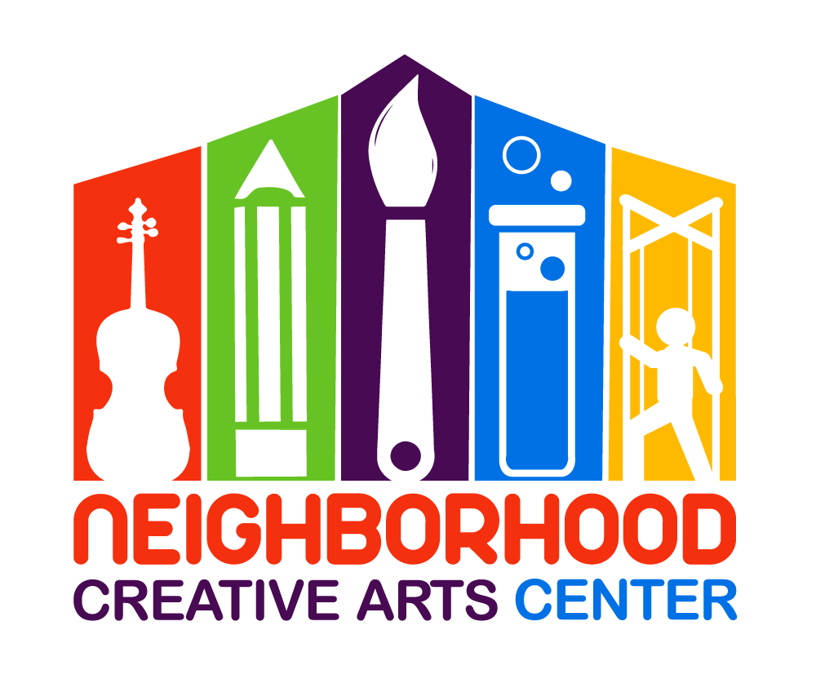
Music Center Individual Lesson Tuition Schedule
(34 weeks of instruction, September 9, 2019 – June 6, 2020)
Please check the desired length of lesson and circle type of payment:
______ 30 minute $110/month for 10 months,
2 semi-annual payments of $525*, or
Full payment of $1100*
______45 minute $140/month for 10 months,
2 semi-annual payments of $700*, or
Full payment of $1400*
*If paying larger tuition fees through Paypal, please include an additional 3% to cover PayPal’s 3% transaction charge. Thank you!
Materials Fee
- Students will need $140 for a year’s supplies. This fee covers music books, binder, backpack, and teaching aids for the year, MMF materials, and recital fees.
This fee must be paid along with registration. Your payment of this fee is a sign of commitment from you, allowing us to reserve your preferred lesson time for your child.

- Theory Workbook, $25: We highly recommend that your child have a theory workbook, which is exceptionally helpful for mastering note, rhythm reading, and a multitude of other music fundamentals. This workbook is for home assignments and will speed along your child’s musical progress. Your child’s theory workbook will be chosen appropriate to their age and knowledge level. Please initial below if you would like a theory notebook for your child. If your child has completed their previous theory workbook, please write the book name below and they will receive the next theory book in the series.
____ Yes, I would like a theory workbook for my child and am including an extra $25 to cover the additional cost. I will pay this in addition to the Materials fee at time of registration.
My child has completed: ___________________________(previous theory workbook)

Individual Lesson Scheduling Options
Please let us know your top three choices for a lesson time. Days and times lessons available:
Monday (3-8PM):__________________________________________________________________
Tuesday (3-8PM):__________________________________________________________________
Wednesday (3-8PM):_______________________________________________________________
Thursday (3-8PM):_________________________________________________________________
Friday (3-8PM):____________________________________________________________________
Saturday, pending, please include other days as options as well (9AM-2PM): ________________________________________________________________________________
Preferred NCAC Teacher(s) ________________________________________________________
Monthly Music Fest Scheduling
Monthly Music Fests (MMFs) happen on every fourth week of instruction. Ideally, students should attend the same day/time of MMF each month. MMF specialties are listed; please sign up for the appropriate MMF for your child. You can reschedule during the year, but it is best if students are able to establish friendships throughout the year with the other students in their MMF group. The 2019-2020 schedule is below. Please check the MMF your child will be attending. If it becomes apparent that your child would thrive in another MMF and should be moved, Ms. Georgia will contact you.
___Tuesday, 4:30-6:00: All beginning and intermediate music students
___Tuesday, 6:30-8: Advanced piano, voice, and instrumental students (3+ years of study)
___Wednesday, 4:30-6:00: All beginning and intermediate music students
___Wednesday, 6:30-8: All beginning and intermediate music students
___Thursday, 4:30-6:00: Primer group (4-6 years)
___Thursday, 6:30-8: All beginning and intermediate music students
___Friday, 4:30-6:00: Beginning Violin: Pre-Twinkle/ Twinkle Students and Book 1 Students
___Friday, 6:30-8: Intermediate Violin (Book 2) and all Teen students (all instruments, piano, voice)
IMPORTANT
- I have read and agree to the terms of the current Neighborhood Creative Arts Center Registration Form, Financial Agreement and Attendance Agreement.
- I accept full responsibility for my child while at NCAC.
- The following items must be turned in at the time of registration: completed Registration form, Financial Agreement, and Attendance Policy and Materials deposit.
- I understand that my child’s picture may be used in print and electronic media. If I am not comfortable with this, I will notify Ms. Georgia in writing within 2 weeks of registration.
- Payment may be made with cash, checks payable to NCAC, Cash App ($GeorgiaBonney), Venmo (Georgia-Bonney-1), or PayPal (through msgeorgia@neighborhoodcreativeartscenter.org, please include 3% service charge).
- Refunds and credits will not be made for lessons missed or canceled by the student.

___________________________________________________________________________________________
(Signature of Parent, Guardian, or Adult Student) Date

