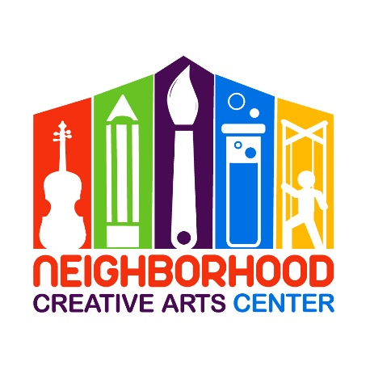
Music Academy Pre-K Piano Lessons
Registration Form for 2020-2021
Due to COVID-19, we will continue our programming virtually, with a continued focus on a unique personalized approach for each student and overall teaching excellence. We will return to live experiences once deemed safe by governmental agencies and the CDC.
Student’s name ____________________________________________________________
Has your child studied music privately previously outside of MGCAA? ___________________________
If so, how long? __________________________Name of last music book studied __________________
Date of Birth (under 18 only) _____________________________ Age ____________________
School attending ______________________________________Grade Level____________
Home address _______________________________________________________________
City__________________________ State________ Zip Code__________________________
Parent or guardian name _______________________________________________________
Daytime phone____________________ Cell phone_______________________
E-mail address ___________________________________________________
Parent or guardian name ________________________________________________
Daytime phone____________________ Cell phone_______________________
E-mail address ____________________________________________________
Are there any personal circumstances of which I should be aware (special needs, allergies, health problems, etc?) No_______ Yes ________ (I am enclosing a confidential explanation.)
Are there any family religious beliefs that might impact repertoire choices or performance dates?
If so, please explain: __________________________________________________________________________
Who may we thank for referring you to us? ________________________________________________________

Music Academy Individual Lesson Tuition Schedule
(34 weeks of instruction, September 8, 2020 – June 5, 2021)
Please circle type of payment:
30 minute lessons $100/month for 10 months,
2 semi-annual payments of $500*, or
Full payment of $1000*
*If paying larger tuition fees through Paypal, please include an additional 3% to cover PayPal’s 3% transaction charge. Thank you!

Materials Fee
Students will need $120 for a year’s supplies. This fee covers music books, binder, backpack, teaching aids for the year, and administrative costs. This fee must be paid along with registration. Your payment of this fee is a sign of commitment from you, allowing us to reserve your preferred lesson time for your child.

Individual Lesson Scheduling Options
Please let us know your top three choices for a lesson time. We have listed the days and times that lessons are available.
Monday (3-8PM):__________________________________________________________________
Tuesday (3-8PM):__________________________________________________________________
Wednesday (3-8PM):_______________________________________________________________
Thursday (3-8PM):_________________________________________________________________
Friday (3-8PM):____________________________________________________________________
Saturday, pending, please include other days as options as well (9AM-2PM): _______________________________________________________________________________
Preferred MGCAA Teacher(s) ________________________________________________________

Your child will attend a Piano Party every fourth week on Thursday, 4:30-5:30 PM, in place of their individual lesson. A Music Fest schedule will be placed in your child’s binder and can be found on the Events page of the NCAC website.

IMPORTANT
- I have read and agree to the terms of the current Neighborhood Creative Arts Center Registration Form, Financial Agreement and Attendance Agreement.
- I accept full responsibility for my child while at NCAC.
- The following items must be turned in at time of registration: completed Registration form, Financial Agreement, and Attendance Policy and Materials deposit.
- I understand that my child’s picture may be used in print and electronic media. If I am not comfortable with this, I will notify Ms Georgia in writing within 2 weeks of registration.
- Payment may be made with cash, checks payable to NCAC or PayPal (through msgeorgia@neighborhoodcreativeartscenter.org, please include 3% service charge).
- Refunds and credits will not be made for lessons missed or canceled by the student.

___________________________________________________________________________________________
(Signature of Parent, Guardian, or Adult Student) Date

