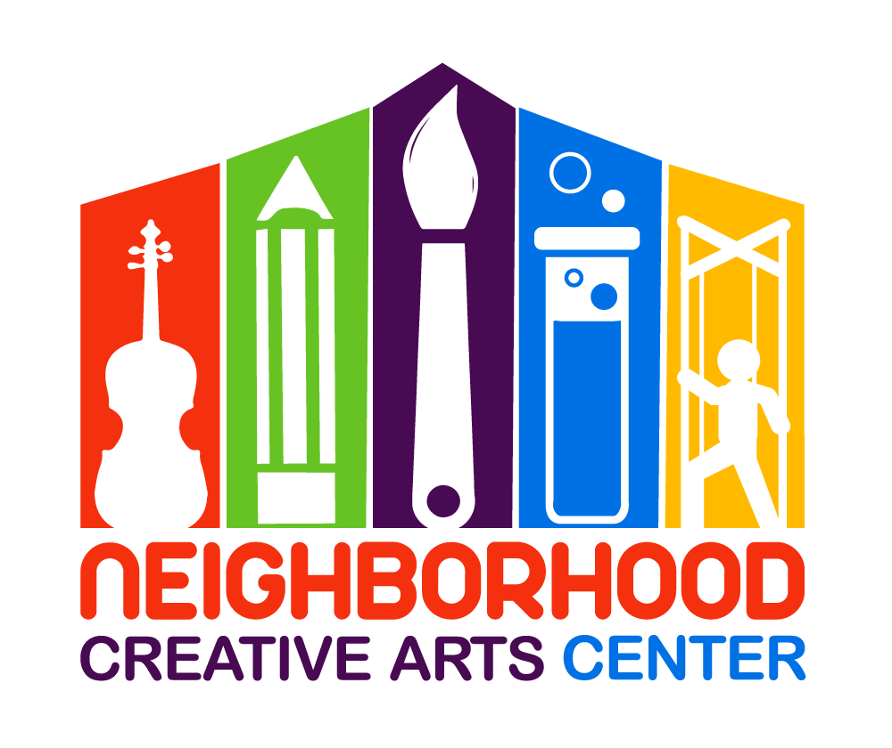
Music Center Individual Lesson
Attendance Agreement for
Adult Student
2019-2020
Thank you for choosing NCAC for your musical adventure! In order to ensure that you get the most effective and creative teaching possible, we have established the following policy regarding attendance.
If you miss a lesson, you will simply miss the benefit of that lesson. Remember that your tuition pays for far more than just lesson time. Your tuition covers your teacher’s preparation time, the time to seek out new music, the time to explore new teaching ideas and methods, their experience and training, studio expenses, and much more.
However, if you foresee that you will be missing a lesson, you may: 1.) opt to use the swap roster to trade lesson times with another student, or 2.) Facetime or Skype for a long-distance lesson from your home, or 3.) simply call to chat about your progress during the time that is reserved for your child. If you choose to swap, you must forward Ms. Georgia the email conversation with the other student confirming the swap to keep everyone informed. If you choose a long-distance lesson, you may Skype your teacher or Facetime/call them during your normal lesson time. Please make these arrangements with Ms. Georgia as soon as possible so your teacher can be informed and plan ahead for the long-distance lesson.
Because you will not be participating in the Monthly Music Fest, you will have lessons for three consecutive weeks and have the fourth week off. We hope this enables you to schedule extra activities with no disturbance to your regularly scheduled lesson time. Missed lessons cannot be made up during the fourth week.
Signature _____________________________________________________________
Today’s Date___________________________________________________________
Email _________________________________________________________________

