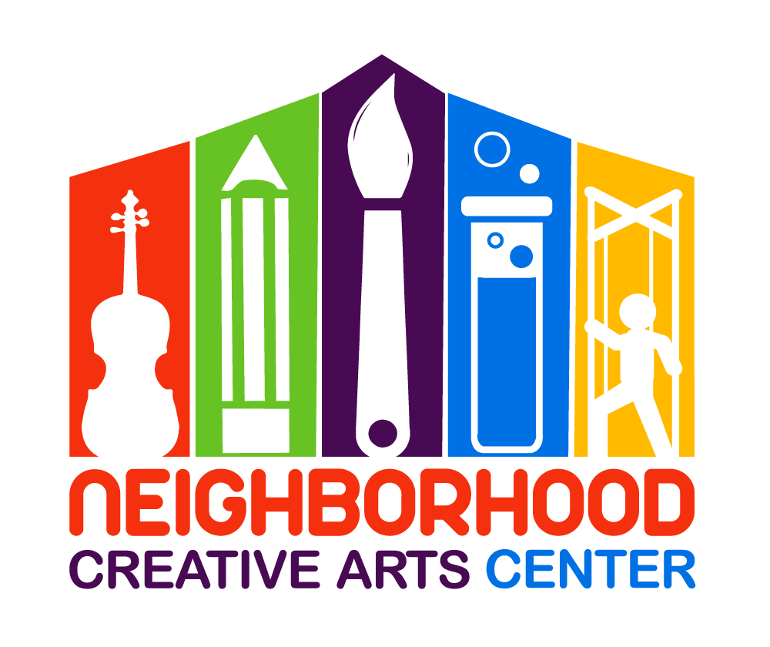

NCAC Saturday Lesson Schedule Changes
2019-2020
We have three schedule changes for our Saturday students. Please mark these in your calendar! Thank you for your flexibility!

No lessons on:
Saturday, November 16, 2019
Saturday, December 7, 2019
Saturday, May 30, 2020
Saturday, June 6, 2019 (MGCAA recital day)

These will be made-up on the Saturdays of Music Fest weeks:

Saturday, November 2, 2019
Saturday, November 30, 2019
Saturday, March 21, 2020
Saturday, April 25, 2020

