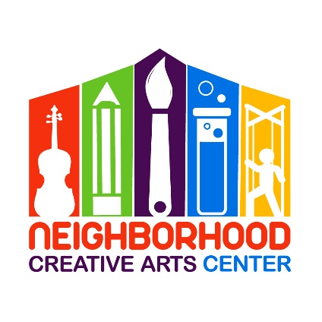

Class Piano
Registration Form for 2020
Term 2: January 11 – June 6, 2020

Student’s name _____________________________________________________________
Term attending: Term 1 Term 2
Date of Birth ______________________________ Age _____________________________
School attending ______________________________________Grade Level____________
Home address _______________________________________________________________
City__________________________ State________ Zip Code__________________________
Parent or guardian name _______________________________________________________
Daytime phone____________________ Cell phone_______________________
E-mail address ___________________________________________________
Parent or guardian name ________________________________________________
Daytime phone____________________ Cell phone_______________________
E-mail address ____________________________________________________

Are there any personal circumstances of which I should be aware (special needs, allergies, health problems, etc?) No_______ Yes ________ (I am enclosing a confidential explanation.)
Are there any family religious beliefs that might impact repertoire choices or performance dates?
If so, please explain: __________________________________________________________________________
Who may we thank for referring you to us? ________________________________________________________

Tuition schedule
Please circle your method of paying tuition: full tuition or payment plan.
Term 2 (16 February, 2020 - 9 June, 2020)
Total Tuition: $320 due January 2, 2020
OR
Payment Plan: $160 due January 2, 2020 and
$160 due February 20, 2020

Materials Fee: $50/term
A materials fee of $50 for each student, which includes expenses for books, CD, extra materials, and recital fee is due with the first tuition payment. Each term, every student will receive new music books and materials, as well as participate in a formal recital.

Scheduling:
Which class time would you prefer? Please circle three and rate in order of preference (#1, #2, #3).

Saturday, 8-9 AM- Adult Class Piano

Saturday,10:15-11:00 AM- Kindergarten- grade 2

Saturday, 11:15 AM-12:00 PM - Grades 3-5

Saturday, 12:15-1:00 PM - Grades 3-5

IMPORTANT
- I have read and agree to the terms of the current Neighborhood Creative Arts Center Registration Form.
- I accept full responsibility for my child while at NCAC.
- The following items must be turned in at time of registration: completed Registration form and Materials deposit.
- I understand that my child’s picture may be used in print and electronic media. If I am not comfortable with this, I will notify Ms. Georgia in writing within 2 weeks of registration.
- Payment may be made with cash, checks payable to NCAC, Cash App ($GeorgiaBonney), Venmo (Georgia-Bonney-1), or PayPal (through msgeorgia@neighborhoodcreativeartscenter.org, please include 3% service charge).
- Refunds and credits will not be made for classes missed by the student.

_________________________________________________________________________
(Signature of Parent, Guardian, or Adult Student) Date

