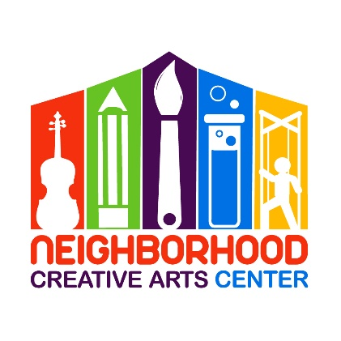
Music Academy Individual Lessons
Financial Responsibility Contract
2020-2021

By signing this agreement, you acknowledge your financial responsibilities to the Neighborhood Creative Arts Center. You are acknowledging that you have read, understand, and agree to our Attendance Agreement.
Tuition may be paid for the entire year, for half year, or in monthly tuition installments. Tuition installments are due on the 20th of each month, August, 2020- May, 2021. Please see detailed summary of tuition below.
A materials fund for each student must be established at the beginning of your musical studies. This includes all administrative fees, assignment binder, backpack, copy fee, music books, MMF materials, and additional fees for the entire year. The annual materials fee is $140/year and must be paid along with registration as a sign of commitment, allowing us to reserve your preferred lesson time for you. Without this payment, your lesson time may be claimed by another student.
Commitment is for a 32-week term and unless we receive a 30-day notification of withdrawal, we assume you will be continuing your musical journey with us until the end of the school year.
Tuition installments paid after the 20th will incur a $15 late fee. If this late fee is not added to the tuition payment, it will be deducted from the materials deposit. Payment not made by the 30th of the month will result in lesson termination. All past-due accounts receive a courtesy email and text/phone call before lesson termination occurs. Should something come up where you cannot financially fulfill your commitment to your music lessons, we appreciate and encourage advanced notice and open, ongoing communication with us.

Tuition Fees for 34 weeks of instruction
30 minute lessons: $1100 total annual payment*
OR
$550* semi-annual payment due August 20, 2020 and
January 20, 2021
OR
10 monthly payments of $110 due on the
20th of each month, August, 2020 through May, 2021

45 minute lessons: $1400 total annual payment*
OR
$700* semi-annual payment due August 20, 2020 and
January 20, 2021
OR
10 monthly payments of $140 due on the
20th of each month, August, 2020 through May, 2021
*If paying larger tuition fees through Paypal, please include an additional 3% to cover PayPal’s 3% transaction charge. Thank you!
** If you are joining mid-term, a prorated Tuition Schedule will be emailed to you, which you will sign in place of this page.

Materials Fee ($140): Due upon registration. Payment of this fee is a sign of your commitment, allowing us to reserve your preferred lesson time for you. Without payment, your preferred lesson time may be claimed by another student.

Theory Book Fee (optional): $25, also due upon registration

Signature _________________________________________________________________
Today’s Date_______________________________________________________________
Email _____________________________________________________________________

MGCAA Individual Lesson
2020-2021 Tuition Schedule

(Please keep this page for your records.)

At time of Registration: $140 materials fee, to reserve lesson time, and theory book fee ($25, optional)

20 August: Tuition Installment #1
20 September: Tuition Installment #2
20 October: Tuition Installment #3
20 November: Tuition Installment #4
20 December: Tuition Installment #5
20 January: Tuition Installment #6
20 February: Tuition Installment #7
20 March: Tuition Installment #8
20 April: Tuition Installment #9
20 May: Tuition Installment #10

Tuition Installment Amounts:
30-minute lessons: $110
45-minute lessons: $140

