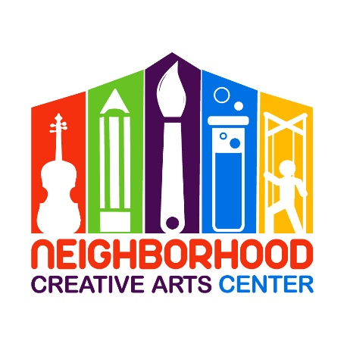
Music Academy Individual Lessons
Registration Form for 2021-2022

Student’s name ____________________________________________________________
Specialty/Specialties to be studied (piano, voice, instrument) ______________________________
Has your child studied music privately previously outside of NCAC or MGCAA? _____________
If so, how long? __________________________Name of last music book studied __________________
Date of Birth (under 18 only) _____________________________ Age ____________________
School attending ______________________________________Grade Level____________
Home address _______________________________________________________________
City__________________________ State________ Zip Code__________________________
Parent or guardian name _______________________________________________________
Daytime phone____________________ Cell phone_______________________
E-mail address ___________________________________________________
Parent or guardian name ________________________________________________
Daytime phone____________________ Cell phone_______________________
E-mail address ____________________________________________________
Are there any personal circumstances of which I should be aware (special needs, allergies, health problems, etc?) No_______ Yes ________ (I am enclosing a confidential explanation.)
Are there any family religious beliefs that might impact repertoire choices or performance dates?
If so, please explain: __________________________________________________________________________
Who may we thank for referring you to us? ________________________________________________________

Music Academy Individual Lesson Tuition Schedule*
(33 weeks of instruction, September 13, 2021 – June 5, 2022)
Please check the desired length of lesson and circle type of payment:
______ 30 minute $115/month for 10 months,
2 semi-annual payments of $575*, or
Full payment of $1150*
______45 minute $150/month for 10 months,
2 semi-annual payments of $750*, or
Full payment of $1500*
*NCAC prefers payment by check or cash, however, if paying through Paypal, please include an additional 3% to cover PayPal’s 3% transaction charge. Thank you!

Materials Fee
- Students will need $140 for a year’s supplies. This fee covers music books, binder, backpack, and teaching aids for the year, MMF materials, and recital fees.
This fee must be paid along with registration. Your payment of this fee is a sign of commitment from you, allowing us to reserve your preferred lesson time for your child.

- Theory Workbook, $25: We highly recommend that your child have a theory workbook, which is exceptionally helpful for mastering note, rhythm reading, and a multitude of other music fundamentals. This workbook is for home assignments and will speed along your child’s musical progress. Your child’s theory workbook will be chosen appropriate to their age and knowledge level. Please initial below if you would like a theory notebook for your child. If your child has completed their previous theory workbook, please write the book name below and they will receive the next theory book in the series.
____ Yes, I would like a theory workbook for my child and am including an extra $25 to cover the additional cost. I will pay this in addition to the Materials fee at time of registration.
My child has completed: ___________________________(previous theory workbook)

Individual Lesson Scheduling Options
Please let us know your top three choices for a lesson time. We have listed the days and times that lessons are available.
Monday (3-8PM):__________________________________________________________________
Tuesday (3-8PM):__________________________________________________________________
Wednesday (3-8PM):_______________________________________________________________
Thursday (3-8PM):_________________________________________________________________
Friday (3-8PM):____________________________________________________________________
Saturday, pending, please include other days as options as well (9AM-2PM): ________________________________________________________________________________
Preferred MGCAA Teacher(s) ________________________________________________________
Would you prefer In-Person or Virtual Lessons? __________________________________________
If the Charles County public schools pivot to a virtual platform due to COVID-19, NCAC will also pivot to a virtual platform.

Monthly Music Fest Scheduling
Monthly Music Fests (MMFs) happen on every fourth week of instruction. Ideally, students should attend the same day/time of MMF each month. MMF specialties are listed; please sign up for the appropriate MMF for your child. You can reschedule during the year, but it is best if students are able to establish friendships throughout the year with the other students in their MMF group. The 2020-2021 schedule is below. Please check the MMF your child will be attending. If it becomes apparent that your child would thrive in another MMF and should be moved, Ms. Georgia will contact you.
___Tuesday, 4:30-6:00: All beginning and intermediate music students
___Tuesday, 6:15-7:45: Advanced piano, voice, and instrumental students (3+ years of study)
___Wednesday, 4:30-6:00: Advanced piano, voice, and instrumental students (3+ years of study)
___Wednesday, 6:15-7:45: All beginning and intermediate music students
___Thursday, 4:30-6:00: Primer group (4-6 years)
___Thursday, 6:15-7:45: All beginning and intermediate music students
___Friday, 5-6:15: Beginning Violin: Pre-Twinkle/ Twinkle Students and Book 1 Students
___Friday, 6:15-7:45: Intermediate Violin (Book 2) and all Teen students (all instruments, piano, voice)
Would you prefer a virtual Music Fest experience? Yes No (please circle)
IMPORTANT
- I have read and agree to the terms of the current Neighborhood Creative Arts Center Registration Form, Financial Agreement and Attendance Agreement.
- I accept full responsibility for my child while at NCAC.
- By attending live lessons, I voluntarily assume all risks related to exposure to COVID-19. Also, by attending live lessons, I affirm that all who attend the lesson are healthy and have not exhibited any signs of illness (COVID-19) in the 14 days before my child’s lesson. If, on the day of the lesson, I or my child are experiencing fever (100.4 degrees or higher) or a sense of having a fever, a new cough that cannot be attributed to another health condition, new shortness of breath that cannot be attributed to another health condition, new chills that cannot be attributed to another health condition, a new sore throat that cannot be attributed to another health condition, or new muscle aches that cannot be attributed to another health condition or specific activity (such as physical exercise), I will schedule virtual lessons until all coming into NCAC have not exhibited signs of illness for 14 days.
- The following items must be turned in at time of registration: completed Registration form, Financial Agreement, and Attendance Policy and Materials deposit.
- I understand that my child’s picture may be used in print and electronic media. If I am not comfortable with this, I will notify Ms Georgia in writing within 2 weeks of registration.
- Payment may be made with cash, checks payable to NCAC or PayPal (through msgeorgia@neighborhoodcreativeartscenter.org, please include 3% service charge).
- Refunds and credits will not be made for lessons missed or canceled by the student.

___________________________________________________________________________________________
(Signature of Parent, Guardian, or Adult Student) Date

