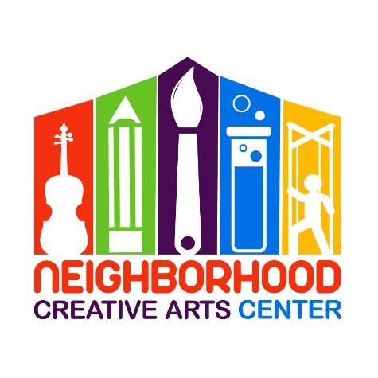
Pre-K Piano
Financial Responsibility Contract
2021-2022

By signing this agreement, you acknowledge your financial responsibilities to the Neighborhood Creative Arts Center. You are acknowledging that you have read, understand, and agree to our Attendance Agreement.
Tuition may be paid for the entire year, for half year, or in monthly tuition installments. Tuition installments are due on the 20th of each month, August 2021- May 2022. Please see detailed summary of tuition below.
A materials fund for each student must be established at the beginning of your musical studies. This includes all administrative fees, assignment binder, backpack, copy fee, music books and accompanying CDs, additional teaching materials, Pre-K Music Fest materials and additional fees for the entire year. The annual materials fee is $120/year and must be paid along with registration as a sign of commitment, allowing us to reserve your preferred lesson time for you. Without this payment, your lesson time may be claimed by another student.
Commitment is for a 33-week term and unless we receive a 30-day notification of withdrawal, we assume you will be continuing your musical journey with us until the end of the school year.
Tuition installments paid after the 20th will incur a $15 late fee. If this late fee is not added to the tuition payment, it will be deducted from the materials deposit. Payment not made by the 30th of the month will result in lesson termination. All past-due accounts receive a courtesy email and text/phone call before lesson termination occurs. Should something come up where you cannot financially fulfill your commitment to your music lessons, we appreciate and encourage advanced notice and open, ongoing communication with us.

Tuition Fees for 33 weeks of instruction**
30 - minute lessons: $1000 total annual payment
OR
$500* semi-annual payment due August 20, 2021
and January 20, 2022
OR
10 monthly payments of $100 due on the
20th of each month, August, 2021 through May, 2022

Payment may be made with cash, checks payable to NCAC, or PayPal (through msgeorgia@neighborhoodcreativeartscenter.org, please include 3% service charge).
** If you are joining mid-term, a prorated Tuition Schedule will be emailed to you.

Materials Fee ($120): Due upon registration. Payment of this fee is a sign of your commitment, allowing us to reserve your preferred lesson time for you. Without payment, your preferred lesson time may be claimed by another student.

Signature _____________________________________________________________
Today’s Date ___________________________________________________________
Email _________________________________________________________________

MGCAA Pre-K Piano
2021-2022 Tuition Schedule
(Please keep this page for your records.)

33 weeks instruction: $1000
Payment Plan: 10 monthly tuition installments of $100

At time of Registration: $120 materials fee, to reserve lesson time
20 August: Tuition Installment #1
20 September: Tuition Installment #2
20 October: Tuition Installment #3
20 November: Tuition Installment #4
20 December: Tuition Installment #5
20 January: Tuition Installment #6
20 February: Tuition Installment #7
20 March: Tuition Installment #8
20 April: Tuition Installment #9
20 May: Tuition Installment #10

