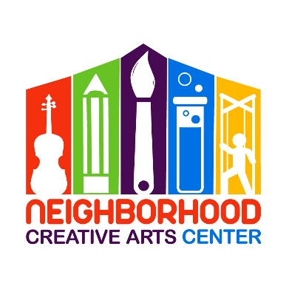
NCAC/TTK Virtual Music Academy
Individual Lessons
Registration Form for 2022-2023

Student’s name ____________________________________________________________
Specialty/Specialties to be studied (piano, voice, instrument) ______________________________
Has your child studied music privately previously outside of NCAC? ___________________________
If so, how long? __________________________Name of last music book studied __________________
Date of Birth (under 18 only) _____________________________ Age ____________________
Home address _______________________________________________________________
City__________________________ State________ Zip Code__________________________
Parent or guardian name _______________________________________________________
Daytime phone____________________ Cell phone_______________________
E-mail address ___________________________________________________
Are there any personal circumstances of which I should be aware (special needs, allergies, health problems, etc?) No_______ Yes ________ (I am enclosing a confidential explanation.)
Are there any family religious beliefs that might impact repertoire choices or performance dates?
If so, please explain: __________________________________________________________________________
Who may we thank for referring you to us? ________________________________________________________

NCAC/TTK Virtual Music Academy Individual Lesson Tuition Schedule**
(33 weeks of instruction, September 12, 2022 – June 3, 2023)
Please check the desired length of lesson and circle type of payment:
______ 30 minute $115/month for 10 months,
2 semi-annual payments of $575 or
Full payment of $1150
______45 minute $150/month for 10 months,
2 semi-annual payments of $750 or
Full payment of $1500

**Full payment for the year, with the materials fee included, can be made through the TTK website. If you prefer to make monthly or semi-annual payments, please reach out to Ms Georgia at msgeorgia@neighborhoodcreativeartscenter.org.
Materials Fee
Students will need $50 for music for the year. This fee is included in the entire cost of tuition when purchasing a year of instruction through TTK.
Individual Lesson Scheduling Options
Please let us know your top three choices for a lesson time. We have listed the days that lessons are available.
Monday:__________________________________________________________________
Tuesday:__________________________________________________________________
Wednesday:_______________________________________________________________
Thursday:_________________________________________________________________
Friday:____________________________________________________________________
Saturday:__________________________________________________________________

Monthly Music Fest Scheduling
Monthly Music Fests (MMFs) happen on every fourth week of instruction. Ideally, students should attend the same day/time of MMF each month. The day/time of your child’s virtual Monthly Music Fest will be arranged to fit the schedules of those students attending.

IMPORTANT
- I have read and agree to the terms of the current NCAC Virtual Music Academy Registration Form, Financial Agreement, and Attendance Agreement.
- The following items must be turned in at time of registration: completed Registration form, Financial Agreement, and Attendance Policy.
- I understand that my child’s picture may be used in print and electronic media. If I am not comfortable with this, I will notify NCAC in writing within 2 weeks of registration.
- Refunds and credits will not be made for lessons missed or canceled by the student.

___________________________________________________________________________________________
(Signature of Parent, Guardian, or Adult Student) Date

